Love Yourself Workshop

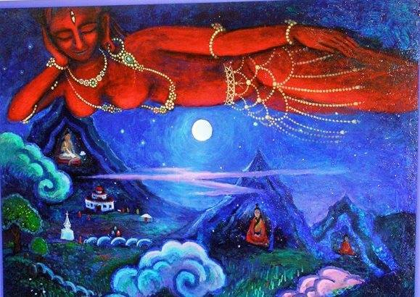
Come join us for a delightfully rejuvenating afternoon of movement, sound, journaling, guided meditation and more …
This class is an opportunity to slow down, release stress, reconnect with yourself … and unite mind, body & spirit. We will engage in a variety of practices that cultivate inner peace & harmony, and plant seeds for increased Self-Trust, Self-Love & Self-Compassion.
Genuine self-acceptance allows us to radiate healthy love out into the world around us. Healthy Self-Love is the necessary foundation of a truly happy life … and one of the most valuable gifts we can give to ourselves and to others.
Together, we’ll go on a journey of:
- sacred mantras, flowing asanas, guided dance steps
- exploration of the essential elements of self-love
- guided visualization, journaling, interactive exercises

When: Saturday 16th February, 2 – 6 pm
Where: Temple Methodist Church, Upper High Street, Taunton
Investment: £25
Please call or email to sign up (and find out what to bring)
Sahina: 077 563 111 46 email: SahinaBella@gmail.com
~ Yogi Tea & delicious snacks provided ~
Svetlana McGraw is a teacher of Kundalini Yoga and Shakti Dance (Yoga of Dance). She had the privilege of training at Amrit Nam Saravar, the International Kundalini Yoga School in the French Alps, 5 years ago.
Sahina Grinczer is a Soul Guide. She trained at The Chaplaincy Institute in San Francisco, California, and uses various transformational tools, including EFT (Emotional Freedom Technique) & The Work of Byron Katie to support her clients in finding a deeper sense of wholeness, peace & clarity. www.Sahina.Weebly.com

